**Project Design Phase-II**

**Solution Requirements (Functional &Non-functional)**

|  |  |
| --- | --- |
| Date |  |
| Team ID | LTVIP2025TMID42361 |
| Project Name | Househunt: Finding Your Perfect Rental  Home |
| Marks |  |

Functional Requirements**:**

Following are the functional requirements of the proposed solution.

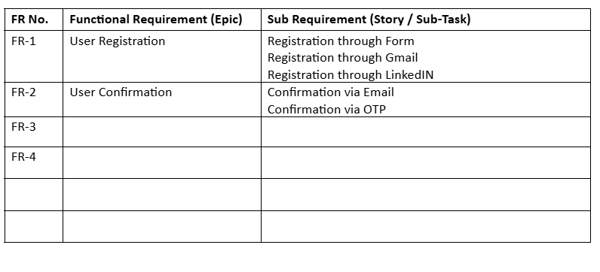

**Non-functional Requirements:**

Following are the non-functional requirements of the proposed solution.

|  |  |  |
| --- | --- | --- |
| **FR No.** | **Non-Functional Requirement** | **Description** |
| NFR-1 | **Usability** | The platform should have a user-friendly interface with intuitive navigation for both freelancers and recruiters. |
| NFR-2 | **Security** | User data and login credentials must be securely stored and transmitted using encryption and authentication protocols. |
| NFR-3 | **Reliability** | The system should consistently function without failures, ensuring data is not lost or corrupted during usage. |
| NFR-4 | **Performance** | The application should respond quickly to user actions and support smooth loading of job listings and forms. |
| NFR-5 | **Availability** | The system should be accessible at least 99% of the time, ensuring minimal downtime for users. |
| NFR-6 | **Scalability** | The platform must support increasing numbers of users and data without performance degradation |